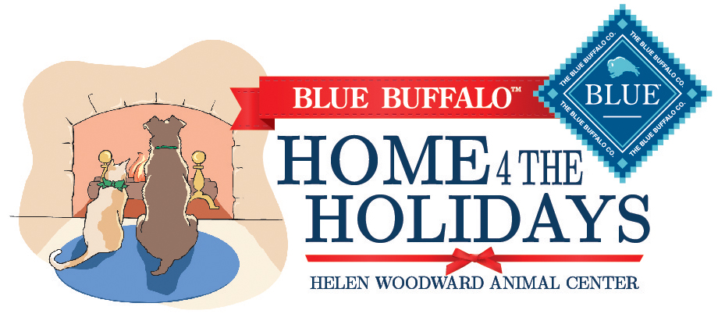

Helen Woodward Animal Center is proud to partner with Blue Buffalo as the official Home 4 the Holidays supporter. Blue Buffalo is again offering two pet food prizes to organizations participating in 2015’s Home 4 the Holidays adoption campaign. **Two selected Home 4 the Holidays partners will win 1,250 pounds of dry dog or cat food for their organization!**

**How Can You Qualify For The Prize?**

The winners will be selected out of a pool of the top participating organizations in this year’s campaign. To qualify organizations must:

* Have timely, weekly adoption reporting continually throughout the campaign
* Submit three or more [Heartwarming Story Contest](http://www.animalcenter.org/home4theholidays/essay_contest.aspx) submissions
  + Stories must have high resolution, clean photos to qualify. Stories without photos will not count toward your total story submission total.
  + Adoptions need to have taken place between October 1, 2015, and January 4, 2016.
  + **Remember: there is no limit to how many stories your organization can send! The more stories – the better! These submissions are also used to qualify you for the $1,000 contest offered by Helen Woodward Animal Center and Blue Buffalo.**

We also appreciate examples of how a How-To Guide tip or principle helped market your adoptable pets:

* + A media story which was in your local news
  + An adoption event or promotion
  + A proclamation that was signed to help orphan pets

**So, remember, to qualify for Blue Buffalo’s pet food prize you must:**

**Do Your Weekly Adoption Reporting:** Report all adoptions, every week, at [www.home4theholidays.org](http://www.home4theholidays.org).

**Submit Heartwarming Stories:** Email your story, WITH PHOTO(S), to [h4th@animalcenter.org](mailto:h4th@animalcenter.org).

If you marketed your adoptable pets using media stories or special Home 4 the Holidays adoption promotions, please email articles, videos or photos to [h4th@animalcenter.org](mailto:h4th@animalcenter.org).

Winners will be notified via the email listed in their organization’s Home 4 the Holidays account in February, 2016.